**User Requirements Specifications**

MDW Group F

Group Members: Preslav Petkov  
 Zigmas Slusnys  
 Aleksandar Asenov

**Russian roulette Game Description:**

**Russian roulette** is a potentially lethal game of chance in which a "player" places a single bullet in a revolver, spins the cylinder (every round), places the muzzle against his head, and pulls the trigger. "Russian" refers to the supposed country of origin, and roulette to the element of risk-taking and the spinning of the revolver's cylinder being reminiscent of spinning a roulette wheel.

Because only one chamber is loaded, the player has a one in *n* chance of hitting the loaded chamber, where *n* is the number of chambers in the cylinder. So, for instance, for a revolver that holds six rounds, the chance is one in six. That assumes that each chamber is equally likely to come to rest in the "correct" position. However due to gravity, in a properly maintained weapon with a single round inside the cylinder, the full chamber, which weighs more than the empty chambers, will usually end up near the bottom of the cylinder, altering the odds in favor of the "player" - but only if the cylinder is allowed to come to a complete stop before the cylinder is relatched.

.

**List of requirements:**

**Functional:**

*Portal:*

|  |  |  |
| --- | --- | --- |
| **Nr** | **Description** | **MOSCOW** |
| **1** | Register | **M** |
| **2** | Login | **M** |
| **3** | Chat | **C** |
| **4** | Invite another player for game | **S** |
| **5** | Game Statistics | **S** |
| **6** | Profile | **W** |

*Game:*

|  |  |  |
| --- | --- | --- |
| **Nr** | **Description** | **MOSCOW** |
| **1** | Determine who goes 1st | **C** |
| **2** | Place bullet in cylinder | **W** |
| **3** | Spin the cylinder | **M** |
| **4** | Pull the trigger | **M** |
| **5** | In Game Chat | **C** |
| **6** | Determine a winner | **M** |
| **7** | Rematch | **C** |

**Non-Functional:**

**Accessibility** – the program is accessible only with internet access. Can be used from anybody who has access to PC and Internet

**Audit and control** – there is no control or audit after the release of the product.

**Backup** – we have an original copy saved, but the clients are responsible for all the further backups.

**Configuration management** – the program is released preconfigured, no further configuration is needed.

**Deployment** – the program will be released as an executable file and send through USB stick or CD. The source code will be also delivered by USB or CD.

**Documentation** – game description, use cases, functional / non-functional requirements, graphical user interface, design document

**Emotional factors** – the software will be user-friendly.

**Interoperability** – the game will work on Windows 7 and Windows 8

**Maintainability** – the program will not be maintained by us.

**Privacy** – First name, last name, e-mail and password are required from the user

**Use Cases:**

**1. Game Use cases**

## Determine who goes 1st

|  |  |
| --- | --- |
| **Name:** | Determine who goes 1st |
| **Actor:** | Player |
| **Pre-Conditions:** | The game has been started |
| **Trigger:** | The actor clicks on the “Play” button |
| **Main Flow:** | 1. Who goes 1st has been randomly generated by the application |
| **Extensions:** | None |

## Spin the cylinder

|  |  |
| --- | --- |
| **Name:** | Spin the cylinder |
| **Actor:** | Both players |
| **Pre-Conditions:** | 1. The game has been started 2. The round has ended 3. There is still no winner |
| **Trigger:** | End of a round |
| **Main Flow:** | 1. The cylinder has been shown in the UI 2. Actor clicks on the “Spin Button” 3. The system spins the cylinder randomly choosing one hole to match the muzzle |
| **Extensions:** | 2.1 Actor Clicks the “Continue” button if he doesn’t wish to spin the cylinder. |

## Pull the trigger

|  |  |
| --- | --- |
| **Name:** | Pull the trigger |
| **Actor:** | Current player |
| **Pre-Conditions:** | 1. The game has been started 2. Use case Nr. 1.2 |
| **Trigger:** | Press the “Fire” button |
| **Main Flow:** | 1. The actor presses the “Fire” button 2. The system notifies both players 3. If it’s a miss – other players turn 4. If it’s a hit- reduces the life of the player who pulled the trigger |
| **Extensions:** | None |

## In Game Chat

|  |  |
| --- | --- |
| **Name:** | In game chat |
| **Actor:** | Player |
| **Pre-Conditions:** | 1. The game has been started |
| **Trigger:** | The actor clicks the “Chat” button |
| **Main Flow:** | 1. The actor enters the message he wishes to send to his opponent in the chat text box 2. The actor presses the “Chat” button to send the message to his opponent 3. Other player is notified for the message and can read it |
| **Extensions:** | None |

## Determine a winner

|  |  |
| --- | --- |
| **Name:** | Determine a winner |
| **Actor:** | Player |
| **Pre-Conditions:** | 1. The game has been started 2. Use case Nr. 1.4 and if it was a hit. |
| **Trigger:** | The actor clicks the “Fire” button |
| **Main Flow:** | 1. The actor presses the “Fire” button 2. The hole of the cylinder in which the bullet was placed matches the gun’s muzzle 3. The opponent player wins |
| **Extensions:** | None |

**2. Portal Use cases**

## Creating a profile

|  |  |
| --- | --- |
| **Name:** | Register |
| **Actor:** | User |
| **Pre-Conditions:** | None |
| **Trigger:** | The actor clicks on the “Register” button. |
| **Main Flow:** | 1. A form appears 2. The actor fills the required information 3. The actor clicks the “Register” Button 4. An account has been created for the actor |
| **Extensions:** | None |

## logging in the portal

|  |  |
| --- | --- |
| **Name:** | Log-in |
| **Actor:** | User |
| **Pre-Conditions:** | Create an account |
| **Trigger:** | The actor clicks on the “Log in” button. |
| **Main Flow:** | 1. A form appears which the actor has to fill 2. The actor fills his e-mail 3. The actor fills his password 4. The actor clicks the “Log in” button 5. The actor logs into his account |
| **Extensions:** | * 1. The username/password are not correct so the actor has to try filling the form with the correct credentials |

## Starting a game

|  |  |
| --- | --- |
| **Name:** | Start a game |
| **Actor:** | User |
| **Pre-Conditions:** | Create an account and log in |
| **Trigger:** | The actor clicks on a player he wants to start a game with. |
| **Main Flow:** | 1. The actor chooses a player he wants to send an invitation for starting a game 2. The actor clicks on the opponent’s profile 3. The actor chooses to send an invitation 4. The game starts if the opponent accepted the request |
| **Extensions:** | * 1. The other player chooses not to accept the game request so the game does not start   2. The actor can choose to send another invitation to the same player or another player |

## Using the group chat

|  |  |
| --- | --- |
| **Name:** | Group chat |
| **Actor:** | User |
| **Pre-Conditions:** | Create an account and log in |
| **Trigger:** | The actor clicks on the chat to start chatting. |
| **Main Flow:** | 1. The actor chooses on the chat to write a message 2. The actor types the message 3. The actor clicks on the “Send” button 4. The message appears in a list box with his name and other online players can see it |
| **Extensions:** | None |

## Starting a personal chat

|  |  |
| --- | --- |
| **Name:** | Start a personal chat |
| **Actor:** | User |
| **Pre-Conditions:** | Create an account and log in |
| **Trigger:** | 1. The actor clicks on a player he wants to start a chat with. |
| **Main Flow:** | 1. The actor chooses a player he wants to start a personal chat with 2. The actor invites him for a game 3. The opponent accepts the invitetion 4. A game has been created by the application where 2 people can chat only between them |
| **Extensions:** | None |
|  |  |

## Checking other player’s profile

|  |  |
| --- | --- |
| **Name:** | See player’s profile |
| **Actor:** | User |
| **Pre-Conditions:** | Create an account and log in |
| **Trigger:** | The actor clicks on a player to check his profile. |
| **Main Flow:** | 1. The actor chooses a player that he wants to check a profile 2. The actor clicks on the opponent’s profile 3. The actor chooses “See profile” button 4. A form pops up showing the opponents profile |
| **Extensions:** | None |

## Logging out

|  |  |
| --- | --- |
| **Name:** | Log out of the portal |
| **Actor:** | User |
| **Pre-Conditions:** | Create an account and log in |
| **Trigger:** | The actor clicks on the button “X”on the top right of the form. |
| **Main Flow:** | 1. The actor clicks on the button “X” |
| **Extensions:** | None |

**Use Case Diagram:**

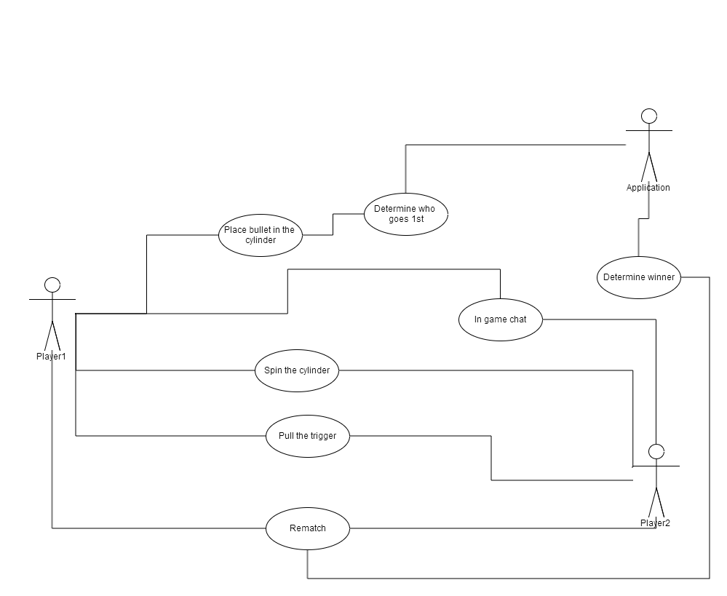

**User Interface Design:**

Login to portal form:

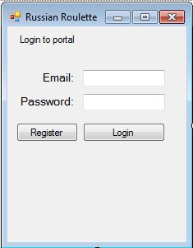

Register to portal form:

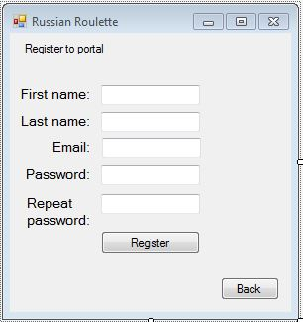

Portal Form:

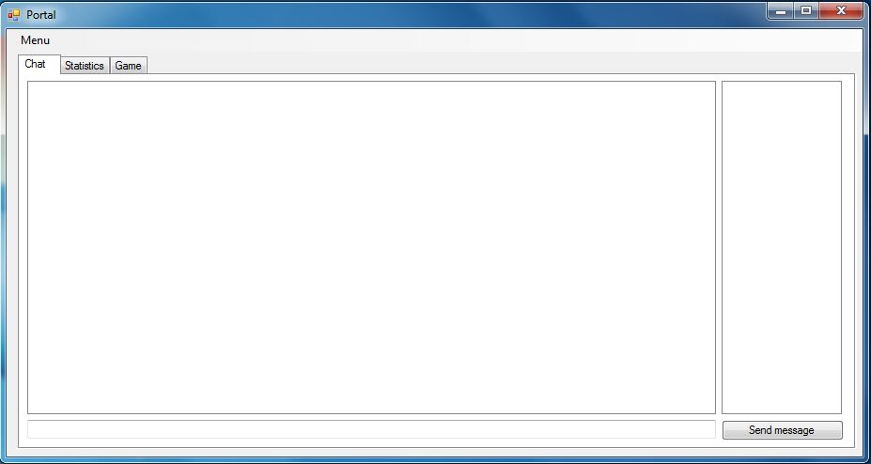

Game form:

